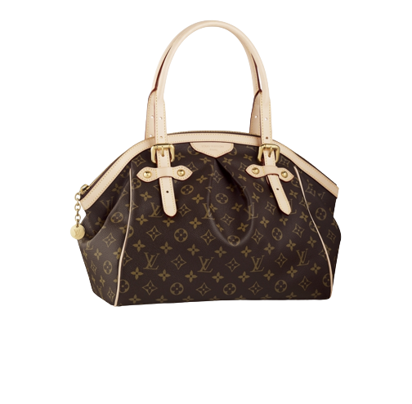

PRODUCT NAME : JAKE MESSENGER

PRODUCT CODE : LV0001

PRICE : **1500000/-**

AFTER DISCOUNTED PRICES

**RS:1125000/-**